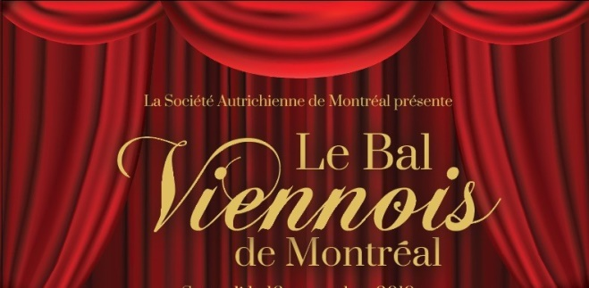
The Austrian Society of Montreal
322 Victoria Avenue
Westmount , QC H3Z 2M8
www.balviennoisdemontreal.org
- facebook.com/vienneseballofmontreal
vienneseballmontreal@gmail.com
Tel.: (514) 484-4545 Fax: (514) 482-6392

Ticket Order Form

Viennese Ball of Montreal

Saturday, November 16, 2019 - Marriott Chateau Champlain

No. of tickets: Regular @ $275/person____ and Junior (30 and under) @ $175/person____ Total: $
Ticket(s) and partial tax receipt will be mailed to: Name

Address

Telephone E-mail

Names of attendees: (and type of ticket each) Please seat me/us with:

Full tables for 10 may be reserved (please add a separate page if needed)

A voucher for free dance lessons with Carole Brown will be sent out for ticket orders received by November 1.

Enclosed is a cheque in the amount of $ payable to “The Austrian Society of Montreal” or charge the amount to my credit card:

VISA / MC #: Expiry date:

Cardholder’s name: (Please print) _

Signature: Date:

No tickets sold at the door

I am unable to attend, but wish to support the fundraising efforts with a tax deductible donation to
“The Austrian Society Trust Fund” in amount of $ _________ (Charity BN / Regis No 118796887 RR0001)

100% of ball proceeds go to the beneficiaries: SOS Children’s Villages, study in Austria for McGill music students,
Leave Out Violence (LOVE), the German Language Schools Quebec, and the Alexander von Humboldt School.

